Haven Acres 10th Annual

**Bowling for Bucks**

November 3rd, 2023 from 6-8pm

C:\Users\Heath11\AppData\Local\Microsoft\Windows\Temporary Internet Files\Content.IE5\7ZMAW9JW\MC900292482[1].wmf  
It’s tough being a kid or teen these days. Suicide and self-injurious behaviors as well as substance abuse and mental health issues in that age group are at all-time highs. Haven Acres offers a safe, country environment where hurting youth find hope, healing, and restoration through their interaction with horses and loving mentors that exhibit the transformational love of Jesus. The design is to pair one child with one mentor and one horse that will work together on a weekly basis. A child between the ages of 9-17 will come out, ***free of charge***, once a week for a 90-minute session. They will help do chores around the farm for the first half of the session and then work with the horse, grooming and learning basic horsemanship for the last half of their session. They will be given opportunities to build confidence, trust and a good work ethic which will help them as they deal with challenges they face now and in the future. **You** have an opportunity to partner with us in reaching out to the youth of our community. We are holding a fundraiser, **Bowling for Bucks**, in order to raise additional funds to help out with needs at the ranch. Each bowler will bowl 3 games on November 3rd, 2023. They will obtain sponsors that will pledge to support them in this cause.

Please indicate below how you would like to help. **Please make checks payable to Haven Acres.** For more information, please visit our website www.havenacresmn.org.

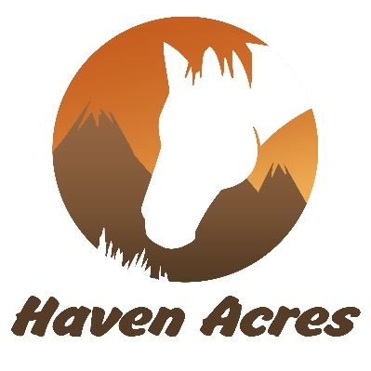I would like to support Haven Acres by pledging __________ / point or giving a one-time donation of _______________.

Haven Acres is a registered 501 (c) 3 organization with the IRS and is a faith-based mentorship program that serves the youth of the Twin Cities Metro Area. Haven Acres exists to demonstrate God’s love by serving youth and their families through mentorship and rescuing animals.

Thank you for partnering with us in this ministry!