Haven Acres 10th Annual

Bowling for Bucks

June 23rd, 2023 from 6-8pm

Name of Bowler: ____________________________________
- Ask friends and family to sponsor you per point or give a flat donation.
- After bowling event, collect pledge money from sponsors.
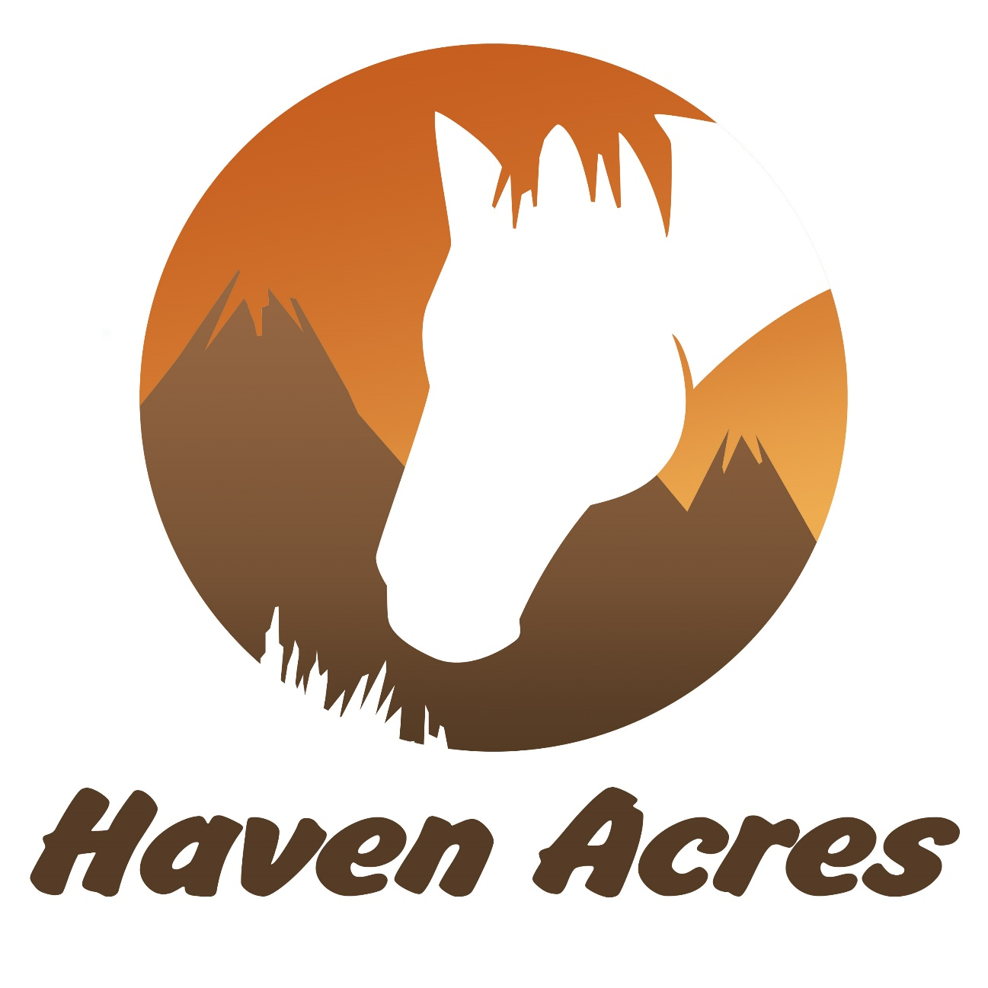
Sponsor Name | Address/E-mail | Pledge Per Point | Flat Donation | Total Due | Amount Paid

